给你一个链表，删除链表的倒数第 n 个结点，并且返回链表的头结点。

示例 1：
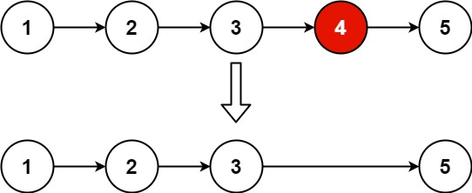
输入：head = [1,2,3,4,5], n = 2
输出：[1,2,3,5]
示例 2：
输入：head = [1], n = 1
输出：[]
示例 3：
输入：head = [1,2], n = 1
输出：[1]

提示：
- 链表中结点的数目为 sz
- 1 <= sz <= 30
- 0 <= Node.val <= 100
- 1 <= n <= sz

进阶：你能尝试使用一趟扫描实现吗？

/**
* Definition for singly-linked list.
* struct ListNode {
* int val;
* ListNode *next;
* ListNode() : val(0), next(nullptr) {}
* ListNode(int x) : val(x), next(nullptr) {}
* ListNode(int x, ListNode *next) : val(x), next(next) {}
* };
*/
//2026.9.3
class Solution {
public:
ListNode* removeNthFromEnd(ListNode* head, int n) {
ListNode* dummyHead = new ListNode(0, head);
ListNode* fast = dummyHead;
ListNode* slow = dummyHead;
for (int i = 0; i < n; i++) {
fast = fast -> next;
}
while(fast -> next) {
fast = fast -> next;
slow = slow -> next;
}
ListNode* temp = slow -> next;
slow -> next = slow -> next -> next;
delete temp;
return dummyHead -> next;
}
};

